Software Requirements Specification

For

Distributed Information System For The Management Of A Library

Version 0.2

Prepared by

Group Name: Black Letters

|  |  |  |
| --- | --- | --- |
| Cucu Sorin Mihai | Grupa CEN 3.1B | [sorinmihai.c09@gmail.com](mailto:sorinmihai.c09@gmail.com) |
| Dicu Cristian Paul | Grupa CEN 3.1B | [dicu.cristian20@gmail.com](mailto:dicu.cristian20@gmail.com) |
| Florea Andrei Cristian | Grupa CEN 3.1B | [andreifcristi19@gmail.com](mailto:andreifcristi19@gmail.com) |
| Craioveanu Vlad Mihail | Grupa CEN 3.1A | [vlad.craioveanu@yahoo.com](mailto:vlad.craioveanu@yahoo.com) |

|  |  |
| --- | --- |
| Instructor: | Stoica Spahiu Cosmin |
| Course: | Project 2 “Use of DataBases” |
| Lab Section: | *Software Engineering* |
| Teaching Assistant: | Sbora Mihai-Catalin |
| Date: | 09.03.2020 |

Contents

Revisions iii

1 Introduction 1

1.1 Document Purpose 1

1.2 Product Scope 1

1.3 Intended Audience and Document Overview 1

1.4 Definitions, Acronyms and Abbreviations 1

1.5 Document Conventions 1

1.6 References and Acknowledgments 2

2 Overall Description 3

2.1 Product Perspective 3

2.2 Product Functionality 3

2.3 Users and Characteristics 3

2.4 Operating Environment 3

2.5 Design and Implementation Constraints 4

2.6 User Documentation 4

2.7 Assumptions and Dependencies 4

3 Specific Requirements 5

3.1 External Interface Requirements 5

3.2 Functional Requirements 6

3.3 Behaviour Requirements 6

4 Other Non-functional Requirements 7

4.1 Performance Requirements 7

4.2 Safety and Security Requirements 7

4.3 Software Quality Attributes 7

5 Other Requirements 8

Appendix A – Data Dictionary 9

Appendix B - Group Log 10

Revisions

| Version | Primary Author(s) | Description of Version | Date Completed |
| --- | --- | --- | --- |
| Draft Type and Number | Full Name | Information about the revision. This table does not need to be filled in whenever a document is touched, only when the version is being upgraded. | 00/00/00 |

# 

# Introduction

## Document Purpose

The purpose of the SRS document is to describe the functionalities of a Distributed Information System for the management of a library.

The document covers the descriptions of all the functionalities, the interfaces, the design elements and all the important information which is needed in order to understand and use the application

## Product Scope

The scope of our application is to give users the possibility, through an easy to use interface, to reserve a book, monitor the borrowed books and purchase a monthly subscription to the library.

## Intended Audience and Document Overview

The intended audience for this document is the developing team, as there as it provides all the functionalities as well as clear details regarding the structure of the application.

## Definitions, Acronyms and Abbreviations

|  |  |  |
| --- | --- | --- |
| Abbreviation Number | Abbreviation | Definition |
| 1 | SRS | A software requirements specification (SRS) is a description of a software system to be developed. The software requirements specification lays out functional and non-functional requirements, and it may include a set of use cases that describe user interactions that the software must provide to the user for perfect interaction. |
| 2 | HTTPS | Hypertext Transfer Protocol Secure (HTTPS) is an extension of the Hypertext Transfer Protocol (HTTP). It is used for secure communication over a computer network, and is widely used on the Internet |
| 3 | FTP | The File Transfer Protocol (FTP) is a standard network protocol used for the transfer of computer files between a client and server on a computer network. |

## Document Conventions

The document uses the following conventions

* Template – SRS
* Font - Times, Arial
* Style - Bold, Italic, noStyle
* Size - 14

## References and Acknowledgments

|  |  |  |
| --- | --- | --- |
| Reference Number | Reference | Description |
| 1 | <https://www.bmc.com/blogs/software-requirements-specification-how-to-write-srs-with-examples/> | Pointers for writing a clear, easy to understand and useful SRS document |
| 2 | <https://en.wikipedia.org/wiki/Software_requirements_specification> | Understanding the concept of an SRS document |

# Overall Description

## Product Perspective

The product is designed to facilitate the access of library visitors to a number of services, without requiring them to go to the library. It also facilitates the process of managing books and subscriptions, by the users or by the employees.

## Product Functionality

The product is going to have the following functionalities:

**2.2.1**

User registration, which provides a list of benefits during the use of the application

**2.2.2**

A list of available books

**2.2.3**

Adding a new book to the list, which is an administrator performed action

**2.2.4**

Accessing the Support / Contact page

**2.2.5**

A section which contains the locations and schedules of the available libraries

**2.2.6**

A donation / borrowing option

## Users and Characteristics

**2.3.1**

Unregistered users are able to:

**2.3.1.1**

Create a user account

**2.3.1.2**

Browse the page

**2.3.1.3**

View the current available books

**2.3.2**

Registered users are able to:

**2.3.2.1**

Edit their personal data

**2.3.2.2**

Purchase a subscription

**2.3.2.3**

Borrow a total number of 5 books

**2.3.2.4**

Donate a book

**2.3.2.5**

Reserve a book

**2.3.3**

Registered users who purchased a monthly subscription are able to:

**2.3.3.1**

Edit their personal data

**2.3.3.2**

Renew their subscription

**2.3.3.3**

Borrow an unlimited number of books

**2.2.3.4**

Donate a book

**2.2.3.5**

Reserve a book for an extended time period

**2.3.4**

Administrators are able to:

**2.3.4.1**

Validate a transaction

**2.3.4.2**

Access the database

**2.3.4.3**

Manage the users

**2.3.4.4**

Perform every action that is available to the registered or unregistered users

## Operating Environment

### Hardware

Web Application Server

Memory: 8GB RAM

CPU: 4 core Intel Xenon @2.2 GHZ

Storage: HDD 10GB

Network: 10Gbps

Database server

Memory: 16GB RAM

CPU: 4 core Intel Xenon @2.2 GHZ

Storage: HDD 100GB

### Software Requirements

Web Application Server:

OS: Windows Server 2016

Application Server: Microsoft IIS

Other applications: .NET Core 3.1 Runtime

Database Server:

OS: Linux RedHat Server

Database Engine: MySQL

Design and Implementation Constraints

The general information must be stored in a database. In order to access the website, an internet connection is required, as well as an internet browser

## User Documentation

Within the application there will be a Contact / Support page, where the perks of every user type will be specified, as well as the conditions for borrowing / donating a book and the terms and conditions

## Assumptions and Dependencies

For the use of this application, an internet connection is required, as well as a web browser (Google Chrome, Mozilla Firefox, Opera, etc)

Assuming there will be no more than 10000 concurrent users, the application will run smoothly, with no performance issues

# Specific Requirements

## External Interface Requirements

### User Interfaces

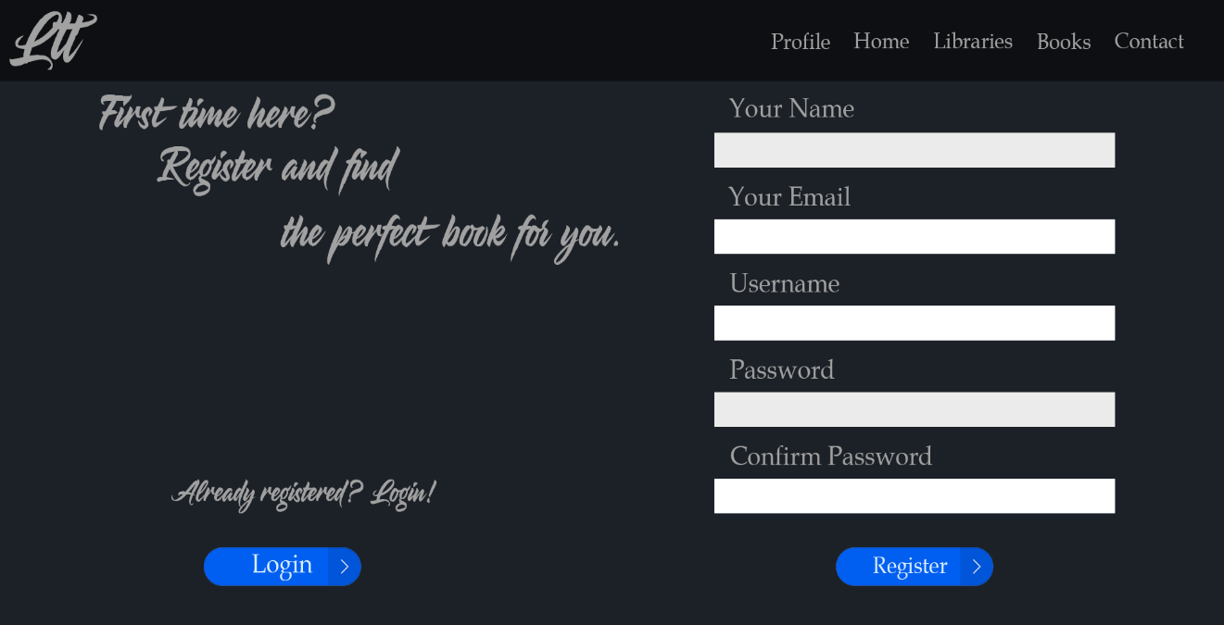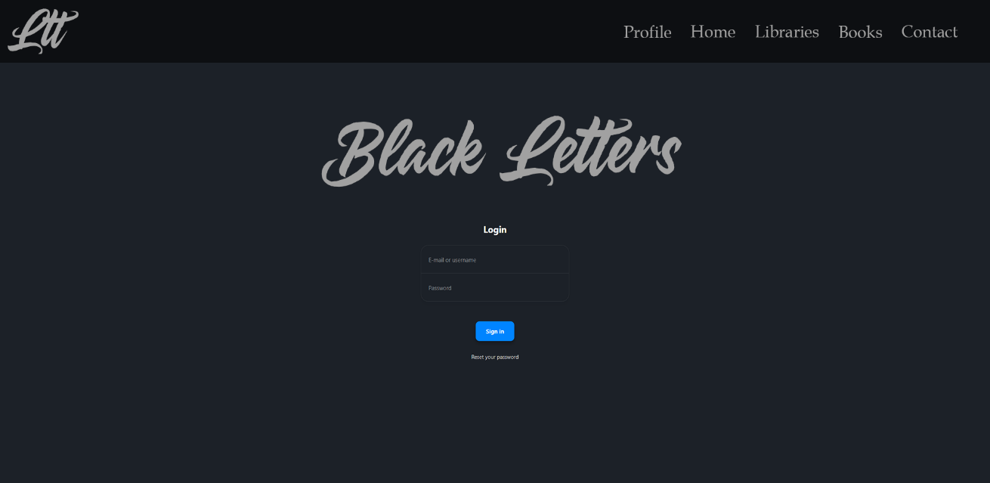

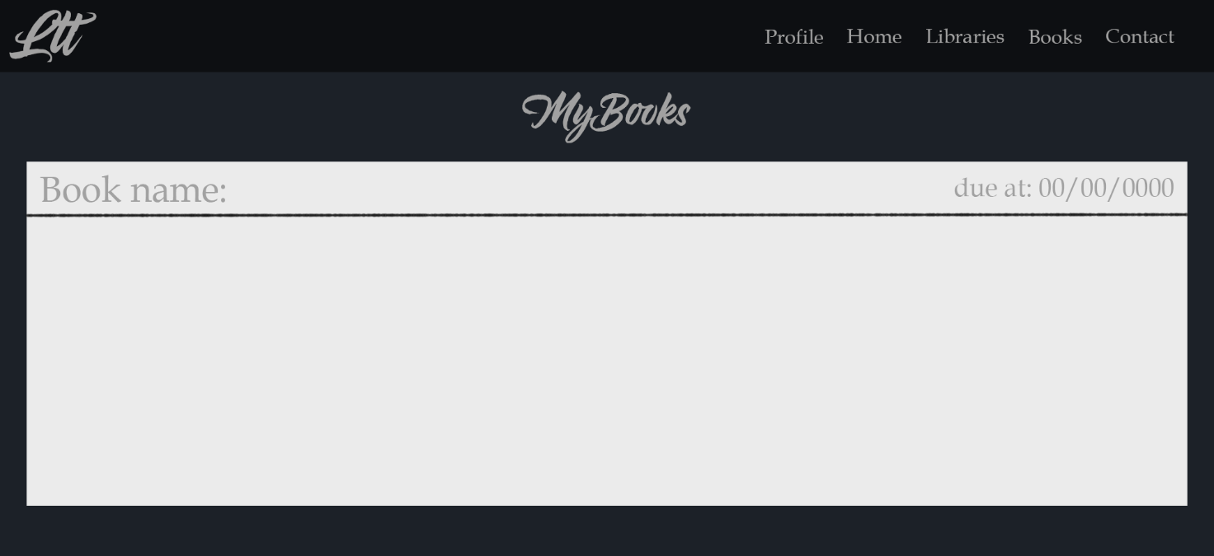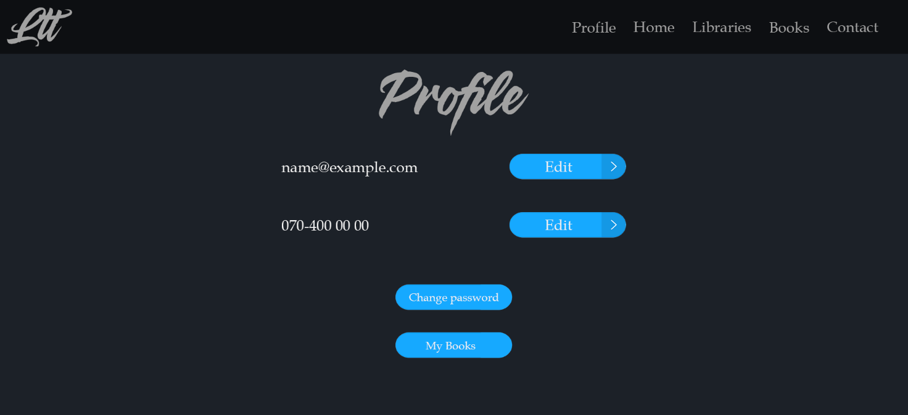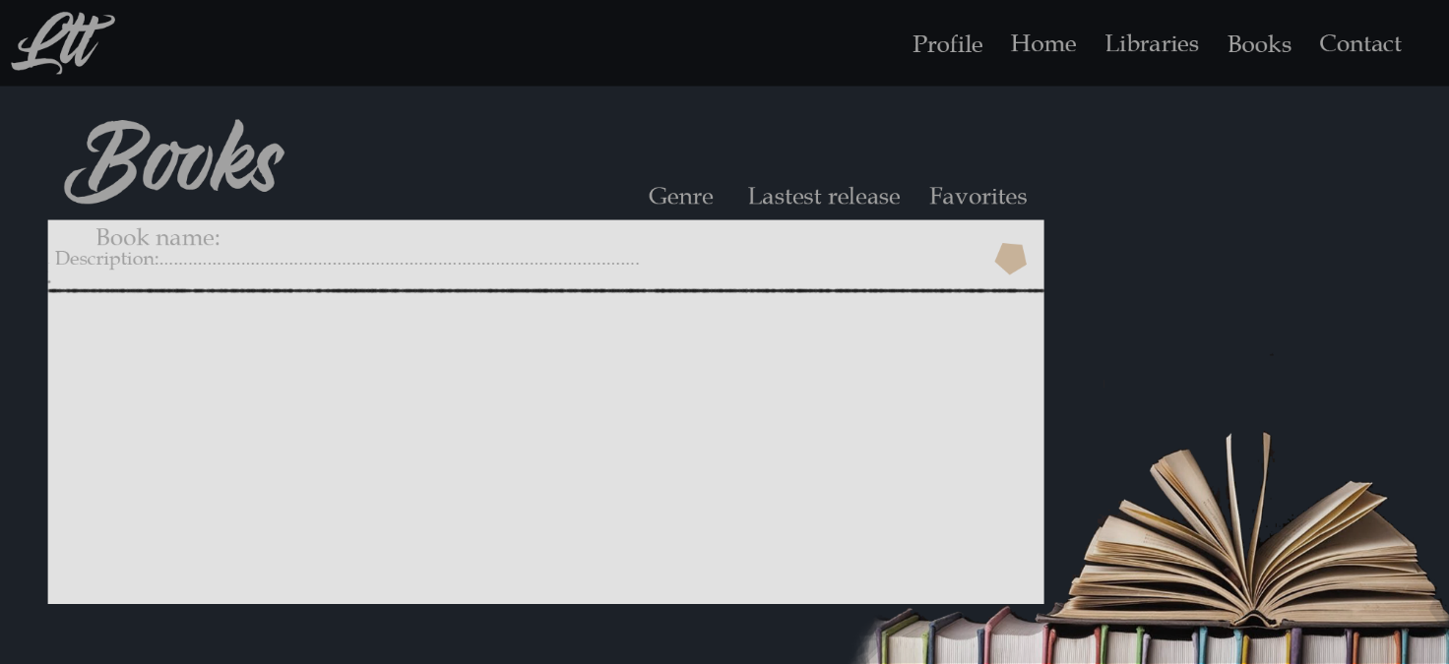

### Communications Interfaces

World Wide Web will be used to create the link between the user and the application.

For security, the HTTPS protocol will be used.

The FTP protocol will be used for file transfers.

## Functional Requirements

The main functional requirements for the application are:

**3.2.1**

Search a book

**3.2.2**

Donate / borrow a book

**3.3.3**

Purchase a subscription

**3.3.4**

Reserve a book

**3.3.5**

Manage the users and the database

## Behaviour Requirements

### Use Case View

# Other Non-functional Requirements

## Performance Requirements

The application must be able to satisfy the following performance requirements:

**4.1.1**

In the event of a system failure, the application will not be compromised.

**4.1.2**

The application will be developed based on an object oriented system.

**4.1.3**

The login data will be stored in database and the correctness the data will be mandatory for accessing the account.

**4.1.4**

There will be multiple methods for data retrieval.

**4.1.5**

The application will run very efficiently in terms of performance and execution time.

## Software Quality Attributes

The application will have the following quality attributes

**4.2.1 Adaptability:**

It can be used by any library

**4.2.2 Accessibility:**

The access is easy and can be performed by anyone

**4.2.3 Correctness:**

The application will run smoothly and efficiently, with a minimum number of errors

**4.2.4 Flexibility:**

The navigation between pages will be easy and intuitive

**4.2.5 Durability:**

In the event of an error, the application will have a competent support staff available

**4.2.6 Portability:**

The application will be accessible from any web browser

The application will be runnable from any computer with a Windows OS and a web browser.

**4.2.7 Reusability:**

The code will be reusable in other applications that have similar structures

**4.2.8 Testing:**

The application will be tested through UniTesting and Integration testing

There will also be performed a User acceptance testing, as well as a whole system testing (manually and automated)

**4.2.9 Utilization:**

The utilization will be intuitive through the easy to use interface

# Other Requirements

## Security Requirements

There will be a login interface which lets the user access their account only if the login data is correctly introduced. The user data will only be available to the user and the administrator.

Appendix A – Data Dictionary

*<Data dictionary is used to track all the different variables, states and functional requirements that you described in your document. Make sure to include the complete list of all constants, state variables (and their possible states), inputs and outputs in a table. In the table, include the description of these items as well as all related operations and requirements.>*

Appendix B - Group Log

<Please include here all the minutes from your group meetings, your group activities, and any other relevant information that will assist the Teaching Assistant to determine the effort put forth to produce this document>